AI ASSISTED CODING (ASSIGNMENT 10.1)

Name: K. Chaithra
Roll No: 2503A52711
Batch: 24

Q1:
Task: Syntax and Logic Errors
Question: Use AI to identify and fix syntax and logic errors in a faulty
Python script.
Sample Input Code:
# Calculate average score of a student
def calc_average(marks):
total = 0
for m in marks:
total += m
average = total / len(marks)
return avrage # Typo here
marks = [85, 90, 78, 92]
print(&quot;Average Score is &quot;, calc_average(marks)
Expected Output:
• Corrected and runnable Python code with explanations of the fixes.
Prompt: Fix all syntax and logic errors in this Python code. Correct the indentation, variable name, and missing parenthesis. Provide the corrected code and explain the errors briefly.
Code:
def calc_average(marks):
total = 0
for m in marks:
total += m
average = total / len(marks)
return average
marks = [85, 90, 78, 92]
print("Average Score is", calc_average(marks))
Output:
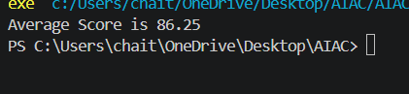
Q2:
Task: Use AI to refactor Python code to follow PEP 8 style
guidelines.
Sample Input Code:
def area_of_rect(L,B) : return L*B
print(area_of_rect(10,20))
Expected Output:
• Well-formatted PEP 8-compliant Python code.
Prompt: Refactor this Python code to follow PEP 8 style guidelines. Fix spacing, indentation, variable names, and line breaks while keeping the same functionality. Provide the corrected code.
Code:
def area_of_rectangle(length, breadth):
return length * breadth
print(area_of_rectangle(10, 20))
Output:
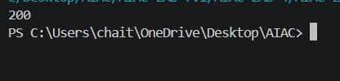
Q3:
Task Description #3 – Readability Enhancement
Task: Use AI to make code more readable without changing its
logic.
Sample Input Code:
def c(x,y):
return x*y/100
a=200
b=15
print(c(a,b))
Expected Output:
• Python code with descriptive variable names, inline
comments, and clear
prompt: Improve the readability of this Python code without changing its logic. Use descriptive function and variable names, proper indentation, and inline comments. Keep the output the same.
Code:
# Calculate a percentage of a given value
def calculate_percentage(value, percentage):
return value * percentage / 100
# Store the original value and percentage
total_value = 200
percentage_value = 15
# Display the calculated result
print(calculate_percentage(total_value, percentage_value))
Output:
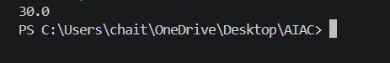
Q4:
Task Description #4 – Refactoring for Maintainability
Task: Use AI to break repetitive or long code into reusable
functions.
Sample Input Code:
students = [&quot;Alice&quot;, &quot;Bob&quot;, &quot;Charlie&quot;]
print(&quot;Welcome&quot;, students[0])
print(&quot;Welcome&quot;, students[1])
print(&quot;Welcome&quot;, students[2])
Expected Output:
• Modular code with reusable functions.
Prompt: Refactor this Python code by creating a reusable function to avoid repetitive print statements. Use proper function names, indentation, and comments. Keep the same output.
Code:
# List of student names
students = ["Alice", "Bob", "Charlie"]
# Function to welcome a student
def welcome_student(name):
print("Welcome", name)
# Welcome all students using the reusable function
for student in students:
welcome_student(student)
output:
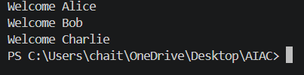
Q5:
Task Description #5 – Performance Optimization
Task: Use AI to make the code run faster.
Sample Input Code:
# Find squares of numbers
nums = [i for i in range(1,1000000)]
squares = []
for n in nums:
squares.append(n**2)
print(len(squares))
Expected Output:
• Optimized code using list comprehensions or vectorized
operations.
Prompt: Optimize this Python code to improve performance. Use a list comprehension instead of a for loop and append operation. Keep the same functionality and output, and briefly explain the changes.
Code:
# Find squares of numbers efficiently
squares = [n**2 for n in range(1, 1000000)]
# Print the total number of squares
print(len(squares))
output:
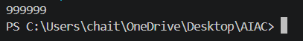
Q6:
Task Description #6 – Complexity Reduction
Task: Use AI to simplify overly complex logic.
Sample Input Code:
def grade(score):
if score &gt;= 90:
return &quot;A&quot;
else:
if score &gt;= 80:
return &quot;B&quot;
else:
if score &gt;= 70:
return &quot;C&quot;
else:
if score &gt;= 60:
return &quot;D&quot;
else:
return &quot;F&quot;
Expected Output:
• Cleaner logic using elif or dictionary mapping.
Prompt: Simplify this Python code by replacing nested if-else statements with elif statements. Improve readability, maintain the same grading logic, and provide the corrected code with a brief explanation.
Code:
# Function to calculate the grade based on score
def grade(score):
if score >= 90:
return "A"
elif score >= 80:
return "B"
elif score >= 70:
return "C"
elif score >= 60:
return "D"
else:
return "F"
# Example usage
score = 85
print("Grade:", grade(score))
output:
